# Management

## Software used

The project was developed on a combination of Windows and Linux operating systems.

The project was mostly developed on the Windows operating system, although a lot of it was written on Linux, Ubuntu Distribution. The main text editor used was Sublime Text 3, because it was cross platform and runs the same on both Windows and Linux. Visual Studio 2015was used to debug the project on Windows, and a combination of GDB and Visual Studio Code were used to debug it on Linux.

## Version Control

The project used Git as its primary version control system, storing the code on the website GitHub. The code is available here: <https://github.com/CaptainSeagull/Preprocessor>.

The reason for choosing Git was because it is free, unlike Perforce, and it was very easy to set up using a custom repository on a website. Another reason for choosing Git was because it allows you to have a full version of the reposition stored locally on your computer, in the *.git* directory, which means the project could still be worked on when the internet was temporarily unavailable, which is not as easy to do with Apache Subversion. At the time of writing, there have been over 400 commits, which show that the project has been developed in rapid, small chunks. This allows older commits to be viewed in isolation with a focus on the feature added, because the commits are generally small.

## Gantt charts

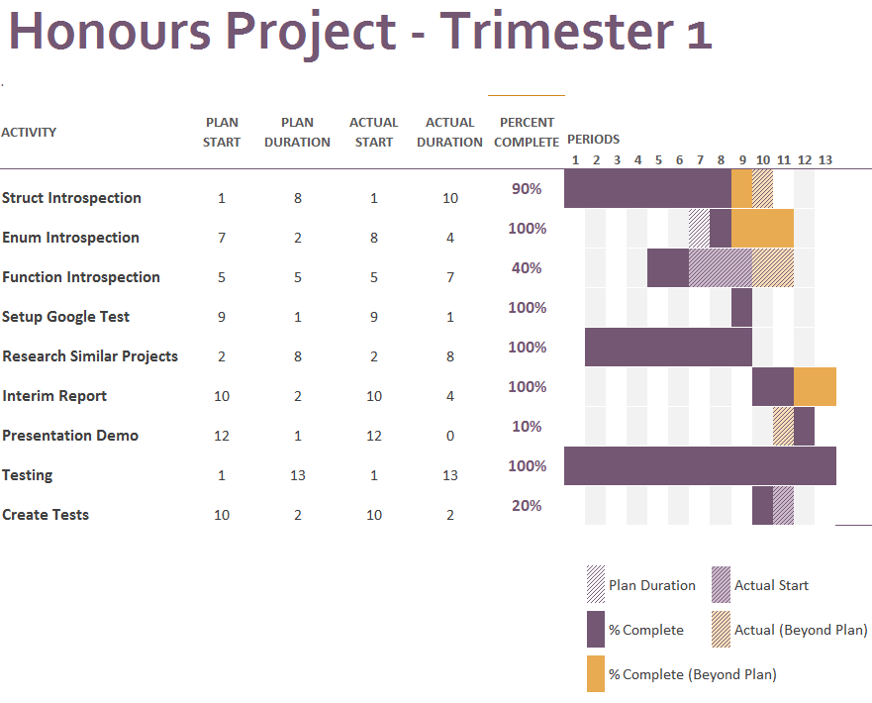

Figure 1 - Gantt Chart of progress for Trimester 1.

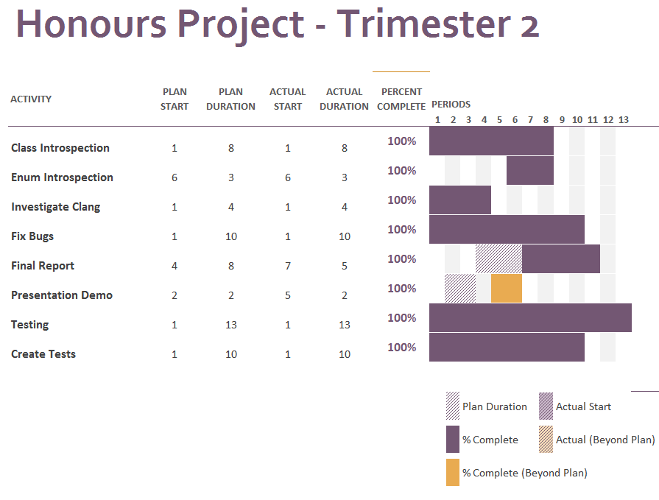

Figure 2 - Gantt Chart of progress for Trimester 2.

## Iterative Development

The project was developed using a very iteration-based development cycle. Having small development cycles of two weeks has allowed a lot of work to be done on the project, and has managed to keep the scope of the project in check (Beck et all, 2001).

The project development has also been very flexible, and a lot of the planning has been added during development. This development style has meant that the focus of the project has constantly been checked, and priority has been given to the most important features.

**FORM A**

**COMPUTING HONOURS PROJECT (COMP10034)**

**PROGRESS AND MANAGEMENT MEETING AGENDA**

*(To be completed* ***before*** *the scheduled meeting)*

**Student:** Jonathan Livingstone **Supervisor:** Paul Keir

**Meeting Number:** 1 **Date/Time:** 04/10/2016 - 2:00pm

**PROGRESS**

Over the last month, the following tasks have been completed:

* Complete honours spec
* Very basic prototype
* Read up on related literature

**AGENDA FOR FORMAL MEETING (Example)**

* Discuss the progress so far.
* Discuss the Dissertation and Interim Report.
* Setting of tasks and planned targets before next formal meeting.
* Set a date for next formal meeting.

**FORM B**

**COMPUTING HONOURS PROJECT (COMP10034)**

**MANAGEMENT MEETING MINUTES AND PLAN**

*(To be completed* ***after*** *the scheduled meeting)*

**Student:** Jonathan Livingstone **Supervisor:** Paul Keir

**Meeting Number:** 1 **Date/Time:** 04/10/2016 - 2:00pm

**MINUTES**

The following tasks and issues were discussed and specific actions agreed:

* Document the project more, and add a "readme" on the repo page.
* Change the structure of the generated code, so there's a file for "static" code, and each .cpp file in a project gets its own generated file.
* Continue to develop the application so it works with more C++ features.

**PLAN**

The following tasks and timelines have been agreed both for the next month and beyond:

For the next month:

* Have a readme showing how to use the project.
* Have some examples of how the project can be used.
* Have a "static" file, which holds the code that isn't changed.

Beyond the next month

* Work on the application so it can work with a wider range of C++ features.
* Make the file structure so every file parsed gets its own generated file.

**FORM A**

**COMPUTING HONOURS PROJECT (COMP10034)**

**PROGRESS AND MANAGEMENT MEETING AGENDA**

*(To be completed* ***before*** *the scheduled meeting)*

**Student:** Jonathan Livingstone **Supervisor:** Paul Keir

**Meeting Number:** 2 **Date/Time:** 14/11/2016 - 2:00pm

**PROGRESS**

Over the last month, the following tasks have been completed:

* Complete a readme showing how to use the project.
* Have a basic prototype showing an example of how the preprocessor could be used.
* Pulled out non-changing code into a "static" file which isn't generated.

**AGENDA FOR FORMAL MEETING (Example)**

* Discuss the progress so far.
* Discuss next steps for implementation.
* Setting of tasks and planned targets before next formal meeting
* Set a date for next formal meeting.

**FORM B**

**COMPUTING HONOURS PROJECT (COMP10034)**

**MANAGEMENT MEETING MINUTES AND PLAN**

*(To be completed* ***after*** *the scheduled meeting)*

**Student:** Jonathan Livingstone **Supervisor:** Paul Keir

**Meeting Number:** 2 **Date/Time:** 14/11/2016 - 2:00pm

**MINUTES**

The following tasks and issues were discussed and specific actions agreed:

* Discuss the technical progress so far, in comparison to last meeting.
* Discuss the interim report and how to tackle it.

**PLAN**

The following tasks and timelines have been agreed both for the next month and beyond:

For the next month:

* Have a more robust better testing framework.
* Start having some more *tricky* examples of how the framework can be used.
* Complete a draft interim report.
* Create a Gantt chart.
* Track tests and examples used by a competing reflection system.

Beyond the next month

* Continue to develop the application.
* Finish the interim report.

**FORM A**

**COMPUTING HONOURS PROJECT (COMP10034)**

**PROGRESS AND MANAGEMENT MEETING AGENDA**

*(To be completed* ***before*** *the scheduled meeting)*

**Student:** Jonathan Livingstone **Supervisor:** Paul Keir

**Meeting Number:** 3 **Date/Time:** 01/12/2016 - 2:00pm

**PROGRESS**

Over the last month, the following tasks have been completed:

* Added Google Test to the project.
* Added introspection to enums.
* Now generate one .h per project file with static members, for scalability.
* Create a Gantt chart.

**AGENDA FOR FORMAL MEETING (Example)**

* Discussion of literature review.
* Discussion of interim report.
* Discuss further features.
* Set a date for next formal meeting.

**FORM B**

**COMPUTING HONOURS PROJECT (COMP10034)**

**MANAGEMENT MEETING MINUTES AND PLAN**

*(To be completed* ***after*** *the scheduled meeting)*

**Student:** Jonathan Livingstone **Supervisor:** Paul Keir

**Meeting Number:** 3 **Date/Time:** 01/12/2016 - 2:00pm

**MINUTES**

The following tasks and issues were discussed and specific actions agreed:

* How to deal with the interim report.
* Tidy up some of the features a little.

**PLAN**

The following tasks and timelines have been agreed both for the next month and beyond:

For the next month:

* Finish the first draft of the interim report.
* Handle any bugs that come up.

Beyond the next month

* Support for C++ features for introspection.
* Finish the full report.
* Prepare a demo.

**FORM A**

**COMPUTING HONOURS PROJECT (COMP10034)**

**PROGRESS AND MANAGEMENT MEETING AGENDA**

*(To be completed* ***before*** *the scheduled meeting)*

**Student:** Jonathan Livingstone **Supervisor:** Paul Keir

**Meeting Number:** 4 **Date/Time:** 19/01/2017 - 2:00pm

**PROGRESS**

Over the last month, the following tasks have been completed:

* Finish interim report.
* Investigated replacing parser with Clang.
* General code tidying.

**AGENDA FOR FORMAL MEETING (Example)**

* Discuss interim report.
* Discuss what is still to be done.
* Set a date for next formal meeting.

**FORM B**

**COMPUTING HONOURS PROJECT (COMP10034)**

**MANAGEMENT MEETING MINUTES AND PLAN**

*(To be completed* ***after*** *the scheduled meeting)*

**Student:** Jonathan Livingstone **Supervisor:** Paul Keir

**Meeting Number:** 4 **Date/Time:** 19/01/2017 - 2:00pm

**MINUTES**

The following tasks and issues were discussed and specific actions agreed:

* Attempt to replace the custom parser with Clang.
* Issues with building Clang on windows.

**PLAN**

The following tasks and timelines have been agreed both for the next month and beyond:

For the next month:

* Attempt to get Clang building from source.
* Handle any bugs that come up.

Beyond the next month

* Support more C++ features for introspection.
* Finish the full report.
* Prepare a demo.

**FORM A**

**COMPUTING HONOURS PROJECT (COMP10034)**

**PROGRESS AND MANAGEMENT MEETING AGENDA**

*(To be completed* ***before*** *the scheduled meeting)*

**Student:** Jonathan Livingstone **Supervisor:** Paul Keir

**Meeting Number:** 5 **Date/Time:** 02/02/2017 - 10:00am

**PROGRESS**

Over the last month, the following tasks have been completed:

* Investigated replacing parser with Clang.
* Basic support for standard template library.

**AGENDA FOR FORMAL MEETING (Example)**

* Discuss interim report.
* Discuss the presentation.
* Further discuss Clang as a parser.
* Set a date for next formal meeting.

**FORM B**

**COMPUTING HONOURS PROJECT (COMP10034)**

**MANAGEMENT MEETING MINUTES AND PLAN**

*(To be completed* ***after*** *the scheduled meeting)*

**Student:** Jonathan Livingstone **Supervisor:** Paul Keir

**Meeting Number:** 5 **Date/Time:** 02/02/2017 - 10:00am

**MINUTES**

The following tasks and issues were discussed and specific actions agreed:

* Discussion on replacing Clang as the parser, and issues relating to that.
* How to structure the presentation.
* How to generalize some of the code more to work with other C++ STL containers.

**PLAN**

The following tasks and timelines have been agreed both for the next month and beyond:

For the next month:

* Create a presentation which discusses the project and have a small demo ready.
* Generalize the code to work with 2 STL containers.
* Continue working with Clang to verify if replacing the parser with it is an option.

Beyond the next month

* Support more C++ features for introspection.
* Finish the full report.

**FORM A**

**COMPUTING HONOURS PROJECT (COMP10034)**

**PROGRESS AND MANAGEMENT MEETING AGENDA**

*(To be completed* ***before*** *the scheduled meeting)*

**Student:** Jonathan Livingstone **Supervisor:** Paul Keir

**Meeting Number:** 6 **Date/Time:** 09/03/2017 - 3:00pm

**PROGRESS**

Over the last month, the following tasks have been completed:

* Template specialization of introspection data
* Work on report

**AGENDA FOR FORMAL MEETING (Example)**

* Discussion of current approach
* What should be in the report

**FORM B**

**COMPUTING HONOURS PROJECT (COMP10034)**

**MANAGEMENT MEETING MINUTES AND PLAN**

*(To be completed* ***after*** *the scheduled meeting)*

**Student:** Jonathan Livingstone **Supervisor:** Paul Keir

**Meeting Number:** 6 **Date/Time:** 09/03/2017 - 3:00pm

**MINUTES**

The following tasks and issues were discussed and specific actions agreed:

* Discussion on last-minute stuff in project.
* How to structure report.

**PLAN**

The following tasks and timelines have been agreed both for the next month and beyond:

For the next month:

* Finish report.